Incident types
06 November 2025
15:24
- Many organizations have common types of jobs that they perform. Often, these standard jobs contain products, procedures, and services that don't tend to vary.

- Incident types in Microsoft Dynamics 365 Field Service act as templates that allow users to quickly create work orders for these common types of jobs.

What is Incident types
- In field service, an incident type is a template used to define the details of a common, recurring type of service request or work order

Relationships
- Agreements
- Enable for Whatsapp ?

Dependencies -
- Work order
- Agreement
- Products , service , services tasks for incident type use in quote
- Agreements
- Customer assets - for creating the work orders

Category -
e.g -
- HVAC maintainance
- Inspection
- Lawn service

Estimated duration -

Let’s say you have an Incident Type called "AC Maintenance":
- Estimated Duration: 90 minutes
- When a Work Order is created using this Incident Type, the system will:
  - Suggest a 90-minute booking slot.
  - Help dispatchers find available technicians with that time window.
  - Also used in the resource requirement for mentioning required time

Work order
06 November 2025
15:26

Work order -
A work order in field service is a detailed record that outlines a specific service request, such as a repair, installation, or preventive maintenance task.
- A Work Order is the core record in Field Service that represents a job or task to be performed

- Why and For which things we create the work order
- How WO created through
  - Quote
  - Customer asset
- Relation with bookings
- Relation with Asset
- Relation with incident type - which one is created first
- Relationship with bookings
- A Booking (also called a Resource Booking) is created to schedule a resource (e.g., technician) to fulfill the Work Order.
- How bookings are created for (scheduled board)

Relationships-
-One incident type can have multiple work order
-One customer asset can have multiple work orders
-One work order many bookings
--> Work order types -
- Inspection -
  - Purpose: To check the condition of equipment or assets and finding out issues .

- Preventive maintainance - Scheduled maintenance performed before a failure occurs.
- Purpose: To prevent problems before they happen.
  - When used: On a regular schedule (e.g., monthly, quarterly).
How it works:
You set up a Maintenance Plan for customer assets.
The system automatically creates Work Orders at scheduled intervals

- Reactive maintainance - Maintenance performed after a failure occurs.
  - Purpose: To fix problems after they occur.
  - When used: When a customer reports an issue (e.g., AC not working).
  - How it works:
    - A Case is created → leads to a Work Order.
    - Technician is dispatched to repair or replace the faulty item.
  - Goal: To restore functionality as quickly as possible.

Dependencies
- Case
- Quote

The incident Required must be 'YES' for automatically creating the work order incident record and therfore
Products , services and service tasks can be created successfully on create of work order .

Resource requirement -
Customer Request ➝ Work Order ➝ Automatic creation of Resource Requirement on work order creation➝ Schedule Assistant ➝ Booking ➝ Field Execution ➝ Completion ➝ Billing

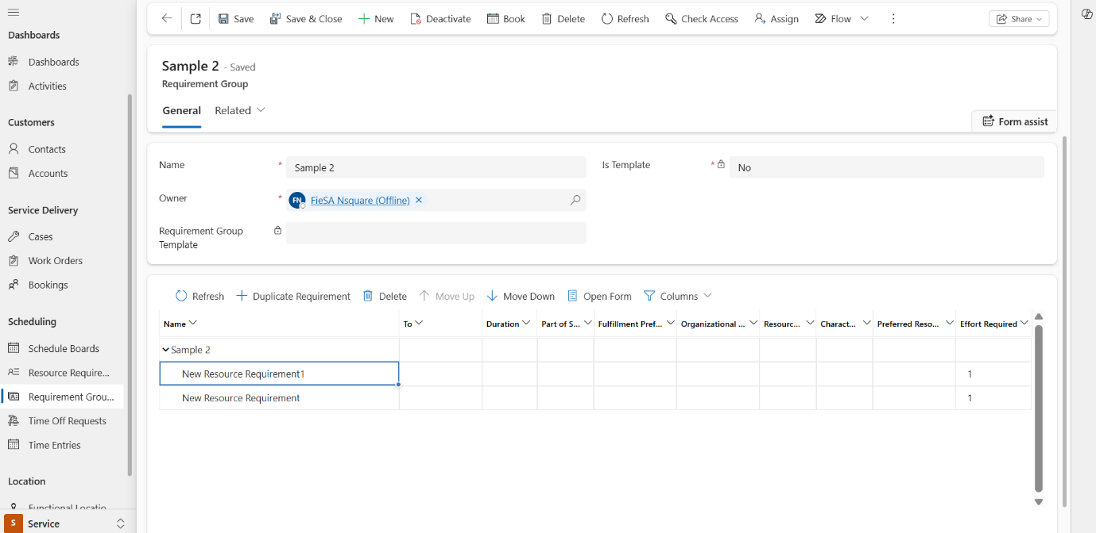

What is a Resource Requirement Group -
A Requirement Group is a collection of multiple resource requirements that are meant to be scheduled as a unit. This is useful when a job requires a team of resources with different roles, skills, or equipment to work simultaneously or in a coordinated manner.

--> Work order substatus use -

Setting -
---> Service tasks
---->where functional locations are used
---->Field service setting - use
----> Job scheduling
---> Inspection scheduling

=> case to bookings -
- Inspection
- Job

Gross Profit margin

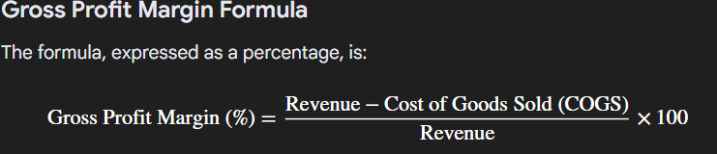

In Fiesa -
Gross profit margin (%) = (Estimate total amount - Estimate unit cost / Estimate total amount ) *100

Agreement and customer asset
06 November 2025
15:59

Agreements are created to formalize and automate long-term service commitments with customers. They serve as a contract-like entity that defines what services will be delivered, how often, and under what conditions

Customer Asset plays an important role in Agreements because it represents the physical equipment or item at the customer’s location that needs service.

- When creating an Agreement, you can link Customer Assets to specify which equipment or machinery the recurring Work Orders will cover.
- Example: HVAC unit, generator, lawn mower at the customer’s site.

Each Work Order generated from the Agreement can reference the Customer Asset, so technicians know exactly what to service.

A customer signs an annual agreement for quarterly maintenance of their HVAC system.
- Agreement → Specifies service frequency and pricing.
- Customer Asset → HVAC unit at the customer’s location.
- Generated Work Orders → Each one references the HVAC asset for clarity and history.

Asset Depreciation refers to the reduction in the value of a physical asset over time due to factors like usage, wear and tear, aging, or obsolescence. In business and accounting terms, it represents how much of the asset’s cost has been “used up” during its useful life.

Product and Asset
06 November 2025
16:22

- Product terms -

- Markup - markup is the gross or total profit on a particular commodity or service
Profit = sale price – cost
Markup Percentage = 100 × (Sale price – Cost Price)/Cost

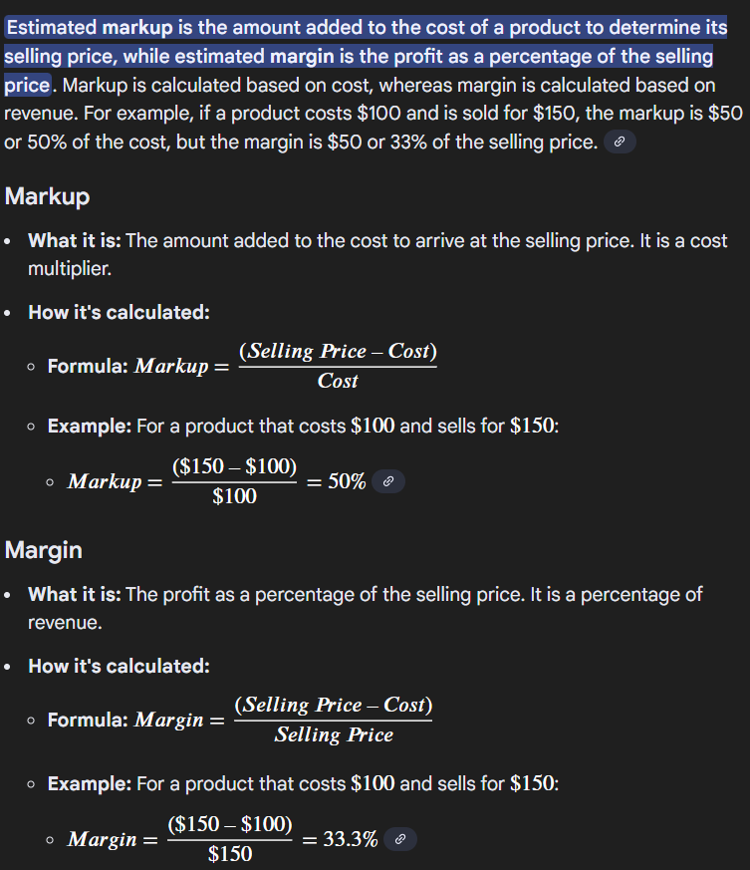

- Difference between asset and product

Product
- Parent product

product types -

Non - inventory -

What is a Non-Inventory Product in Dynamics 365?
A Non-Inventory product is something your company uses or sells, but does not track in stock or warehouse.

✅ Example You Gave:
Cable from a reel — perfect example!
- You use some length of cable (like 10 meters).
- You don’t track how much cable is left on the reel.
- You charge the customer for the 10 meters used.
- But you don’t update inventory every time you use it

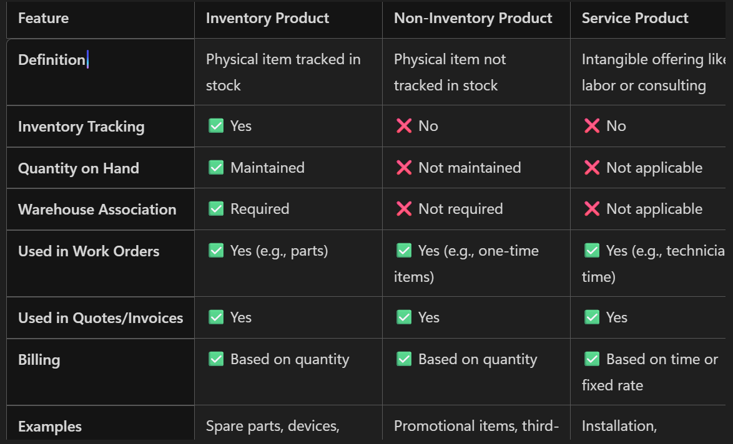

Service tasks -

-Service tasks represent the specific tasks that need to be completed on a work order.
- Uses the service task types for creating the service tasks

Formulas -
Markup % = (selling -cost )*cost
Subtotal = markup + Cost Per Unit
markup amount = markup % *cost per unit
Price per unit = amount in price list item
Cost per unit = price per unit - markup amount
Subtotal = amount in price list item * quantity
Estimated margin % = (selling price - cost )*selling price

Customer Asset-

- Property Values -
  - These are custom attributes or characteristics of a customer asset. e.g - voltage , model number
- Property logs history
a. A record of changes made to the asset’s property values over time

  - Note -
"Decimals Supported" field on a product dictates how many decimal places (typically 0-4) are allowed for quantities in opportunities, quotes, orders, and invoices

Product
- Additional details - price list item - top 1
Amount - selling amount
And current cost - How much it costs the organization to buy or provide that item.

The amount get mapped into the work order product as estimated amount
current cost gets mapped as Estimate unit cost

Case and Scheduled boards
06 November 2025
18:13

- Used for the allocating the resource and timings for a particular bookings
- Used in the work orders while bookings

- Visual resource and job tracking: Provides a real-time view of technician availability and the locations of both scheduled and unscheduled jobs.
- Allows dispatchers to drag and drop work orders directly onto a technician's schedule to create bookings
- Bookings - A Booking is created to schedule the technician for the job.

Schedular boards -
- Individually can schedule booking for any work order
- Creating work order form quote - work orders and booking (inspection & job are created automatically
- Case to booking
  - First create work order then schedule resource and create a booking
- For a particular work order book for resource and timings - new booking will be created.

- Case to booking -
- Issue - case creation
- Case qualify
- Work order creation
- Resource scheduling
- Booking creation

What is a Case in Field Service (Dynamics 365 CRM)
A Case is a record of a customer issue, complaint, or service request.
- It’s usually created by a customer service agent when a customer contacts support.
- It helps track the problem, communication, and resolution process.
- In Field Service, a Case can lead to technical service if the issue needs a technician visit.

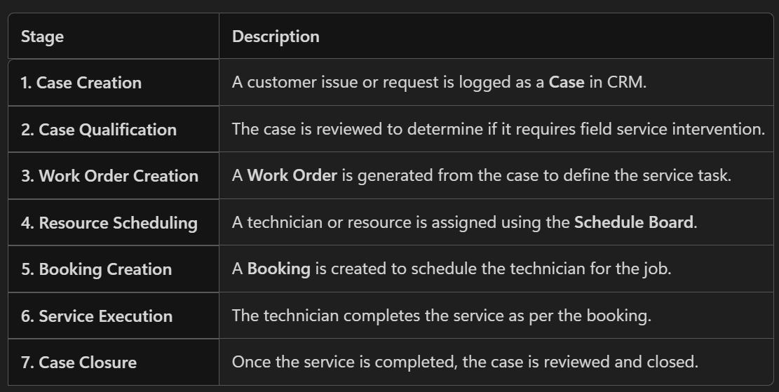

Quote creation -
Why Do We Provide a Quote to the Customer?
A Quote is provided when:
- The issue requires paid service or parts.
- The customer needs to approve the cost before work begins.
- It helps set clear expectations for pricing and scope.

Case Relationship -
- 1:N -Quote -
- 1:N - Work orders

-----

- Slots are scheduled based resource characterstics , work hours, category associations
- Based on these resource factors slots are scheduled for job/inspection.

Quote
07 November 2025
11:47

Quote and its dependencies -

Order type -

=>item based: This order type is designed for the sale or delivery of physical products that are tracked in inventory.

=> Service - maintainance based :What it is: This is a specialized work order for a customer service request, such as a repair, installation, or preventative maintenance.

FieSa Customization
22 November 2025
22:36
Quote

- Quote line products and services are fetched from the incident type

Job Scheduling -

=>Job is scheduled based on the resource characterstics , categories with incident type of case characterstics and categories
- Resource availaible slots on that date and time
- Time To Promised" is the deadline, and "Time From Promised" is the start time of this window

- PPM - Planned preventive maintainance

- The first-time fix rate (FTFR) is a key performance indicator (KPI) used to measure the percentage of maintenance or customer support issues that are resolved during the very first service visit or interaction

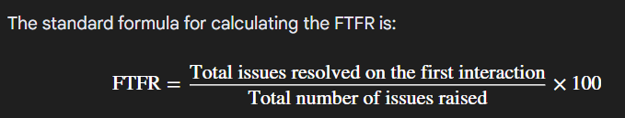

Access of user roles
- Admin – Typically responsible for system configuration, user management, and high-level oversight. They usually don’t create agreements unless acting as a backup.
- Resource – Usually refers to field staff or service personnel. They consume agreements (work orders, bookings) but rarely create them.
- Salesperson – Primary role for creating agreements. They negotiate terms, set up agreements with customers, and initiate the process in CRM.
- Inventory Purchase – Focused on procurement and stock management, not agreement creation.
- Dispatcher – Handles scheduling and resource allocation after agreements exist. They don’t create agreements.
✅ Answer: The Salesperson is generally responsible for creating agreements because agreements are tied to customer commitments and sales processes.

Overall
17 February 2026
17:38

Contact
- Duplication prevention of contact based mobile number
- When added the functional location with creating the contact the contact location is created automatically => Plugin is written for this
Account

- Difference between service account and billing account
Ans -
A company owns multiple branches:
- Mumbai Branch
- Pune Branch
- Dubai Branch
Each branch is a Service Account because technicians go there.

A Billing Account is the account that receives and pays the invoices for the work done at the service locations.

Case
- Case created
Status = Active
Status reason = In Progress
Quote created = In progress

- Sla is triggered based on case creation and priority of incident type => Resolved by and response by = both have same trigger point
- High
- Medium
- Emergency

Response by = Success full on first response sent
Resolved by = success when the case is resolved

Quote

- Quote created
Status = Draft
Status reason = In Progress
Button visibility = send for approval
Total amount >3000

After sending the internal approval
Status = Pending for Internal Approval
All status -
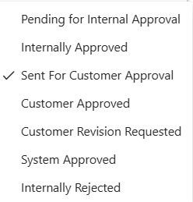

Quote trigger point
- Level 1 and 2
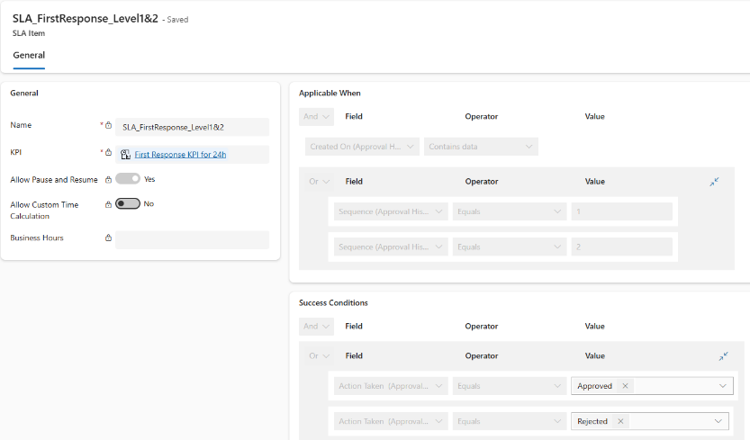

- Level 3
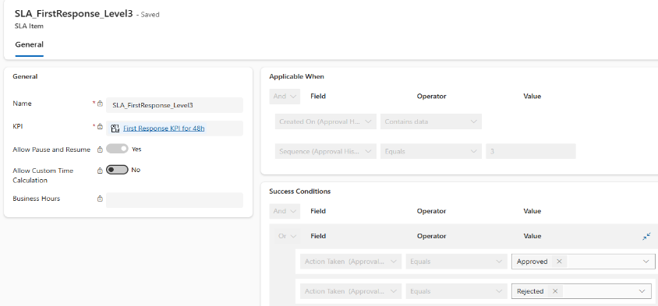

Customer asset
Asset lifecycle
Status =

- 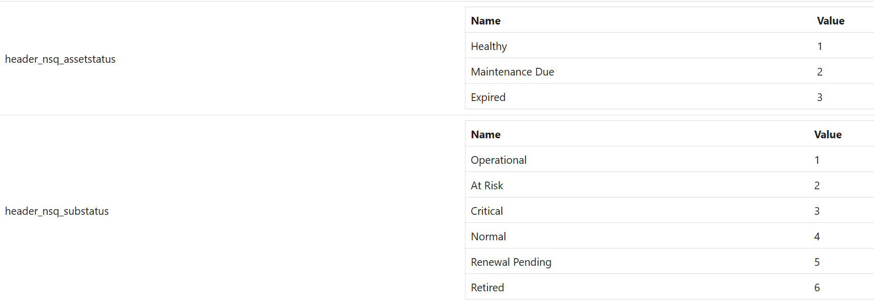

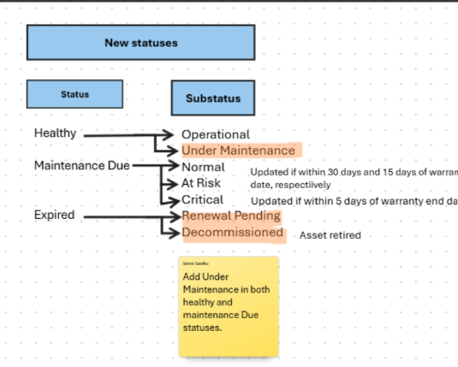

- If the asset is depricated
Status = Expired
Substatus = Expired
Warranty status = Expired

Work order

- Work order service estimated duration comes from the incident type service duration

Questions
17 February 2026
17:41

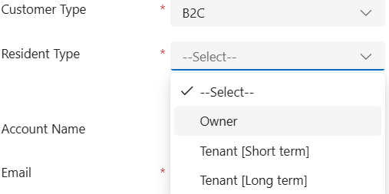

Why ?
Any other customizations

2.Account why product price list ?
Payment terms ?

Case
Where is request type coming from

Price List
19 February 2026
12:16

The products that are added through the Incident Type must also exist on the Price List that the Account (Service Account) uses, otherwise the price on Quote / Work Order will be 0.00.
This is exactly how Dynamics 365 pricing works:
A product must exist as a Price List Item in the selected price list for the system to calculate price. If not → Price = 0.
This applies to both Field Service Work Orders and Sales Quotes.

E.g
Case -
Incident type products
P1 and p2

Account
Price list -
Products - p3 and p4

When quote is created the quote will have p1 and p2 products but it will not carry the price of that particular incident type product it will carry the price from the account price list
So to have the correct pricing of the products - the products should present in the accounts price list as well

Compliances - Checklist
12 December 2025
15:41
Inspection Template Versioning
- When you publish an inspection template, Dynamics creates a version (e.g., Version 1).
- If you revise and publish again, a new version (Version 2) is created.
- Each Work Order Service Task is linked to a specific version of the inspection template.

Technician Completes Checklist in Mobile App
- The technician opens the Work Order in Field Service Mobile.
- The app loads the inspection template version associated with that Work Order.
- Technician answers questions, uploads photos, signs digitally.

Data Sync to CRM
- When the technician submits the inspection:
  - Responses are stored in Inspection Response entity in Dataverse.
  - Each response record references:
    - Inspection Template Version (so CRM knows which version was used).
    - Work Order Service Task.
    - Question ID and Answer.
    - Attachments (photos, signatures).

Why Version Matters
- If you later revise the template (Version 2), existing Work Orders keep Version 1 responses.
- This ensures historical accuracy—CRM knows which version was used for compliance.

Checklist json decode
16 December 2025
11:09
msdyn_inspectionresponse -Answers of the questions saved in this table

The inspection response stores answers in a base64-encoded JSON string

1.
When a row is added or modified → Table: msdyn_inspectionresponse.

2.Decode using
base64ToString(triggerOutputs()?['body/msdyn_responsejson'])

- Add Parse JSON action:
  - Content: Output of the Compose step.

4.Check if ANY question has answer = "No"
- Add Filter Array:
  - From: body('Parse_JSON')?['questions']
  - Condition: item()?['answer'] equals "No"

5.Condition
- After Filter Array, add a Condition:
length(body('Filter_array')) > 0

6.
Update Work Order (msdyn_workorder):
- Set nsq_isblocked = true.

7.
Create Booking Alert:
- Message: “Job blocked: Inspection has a safety question answered as NO.” -js

====================================================

If you enable Inspection Analytics in Field Service Settings → Inspection tab, Microsoft’s out-of-the-box flows will parse the inspection response JSON into Customer Voice tables for question-level reporting:
- msfp_question (each template question)
- msfp_surveyresponse (one response per inspection completion)
- msfp_questionresponse (each answered question, with its value)

Security roles
25 December 2025
13:14

Compliance Checkllist responses

Fiesa- Admin - full access
Fiesa - Resource - Full access
Fiesa - Dispatcher - No access
Fiesa - inventory purchase - No access
Fiesa - salesperson -No access

Compliance
Fiesa- Admin - full access

Calculations
15 December 2025
13:57
Example (with simple numbers)
Inputs
- Purchase Cost = 100,000
- Rate = 20% (WDV)
- Useful Life = 5 years
- Residual Value = 10,000
- Purchase Date = 15-Nov-2024
- Financial Year End = Mar 31 → (3, 31)

First period (partial year)
- Period: 15-Nov-2024 to 31-Mar-2025
- Days in period ≈ 137; Days in year = 365 → proportion ≈ 0.3753
- Full-year depreciation: 100,000 × 20% = 20,000
- Pro-rata depreciation: 20,000 × 0.3753 ≈ 7,506 → rounded = 7,506
- Closing value: 100,000 – 7,506 = 92,494

Second period (full year)
- Period: 01-Apr-2025 to 31-Mar-2026
- Depreciation: 92,494 × 20% = 18,499 → rounded = 18,499
- Closing: 92,494 – 18,499 = 73,995

…and so on, stopping when closing value hits residual (10,000) or after 5 years, whichever comes first. If the last year’s depreciation would take the asset below 10,000, it adjusts so the closing equals exactly 10,000.

Financial year = 31 st march

Asset depriciation
14 January 2026
09:43

Asset Depreciation refers to the reduction in the value of a physical asset over time due to factors like usage, wear and tear, aging, or obsolescence. In business and accounting terms, it represents how much of the asset’s cost has been “used up” during its useful life.

automatically calculate yearly depreciation for assets using the Declining Balance method based on the asset’s annual opening value

Residual value - until a this meets the asset depriciation records will be created

SSG - Slots scheduling
26 December 2025
15:41

SSG
1.Fixed slots of 2 hours
2.Resources are booked based on the the the availaibility based on the time off request and bookings for that particular resource
3.First creating the work order and then bookings for the work order
4.Preferences given based on the total time that particular resource has worked today
5.Booking the job directly from the work order - In crm No separate entity for the particular booking job / Inspection - Runs in background for scheduling the
6.Also Booking the inspection date / Job date can be done through the technician app

Fiesa current slot functionality -
1. Resources are fetched based on the category and characterstics
2. multiple 1 hour slots can be shown on job scheduling with same time but for multiple resources e.g 12pm -1pm for resource1 and 12pm -1pm for resource2 - this functionality is not working properly

Plugin implementation in fiesa-

private DateTime RoundToNextHour(DateTime time)
{
return time.Minute == 0 ? time : time.AddMinutes(60 - time.Minute);
}

Example 3
Input:
13:45
Calculation:
- 60 − 45 = 15 minutes added
Output:
14:00
- sdyn_RetrieveResourceAvailability is a Dataverse custom action (message) from Universal Resource Scheduling (URS) used to return available time slots for bookable resources based on inputs like date range, duration, resources/territories,

Are parameters like StartTime, EndTime, Resources, etc. fixed for this action?
Yes — they are fixed internally.
The action will only accept the parameters it was designed for, such as:
- StartTime
- EndTime
- Duration
- Resources (EntityCollection of bookableresource)
- ForceDateRange
- RealTimeMode
- IgnoreDuration
- IgnoreTravelTime
- AllowOverlapping
- Characteristics
- Territories
- OrganizationalUnits
- BusinessUnits
- Latitude, Longitude, Radius
This list is confirmed through community examples and working sample code. [d365hub.com]
But because Microsoft never published official documentation, these parameters are considered implementation details of URS, not a stable public API.

Correct — msdyn_RetrieveResourceAvailability cannot return existing bookings.

Slot availability
30 December 2025
12:43

Slot availability based on technician preferences, determined by the working time allocated for the selected appointment date -

1.Phase 1: Collect per-resource summaries (availability, exclusions, worked minutes)
var summaries = new List<(
Guid ResourceId,
string ResourceName,
int WorkedMinutesToday,
List<(DateTime StartLocal, DateTime EndLocal)> AvailabilityLocal, -
List<(DateTime StartLocal, DateTime EndLocal)> ExclusionsLocal
)>();

2.Found all the availaible resources
- for every resource - found the avaialibility using the api and existing bookings
s
Exclusionlocal list - consists of the booking local start time and end time -all the start time and end time of all bookings for resource

Looped through the exclusion
- For each - differnece between start and end time
- Int workedMinutesToday += (int)Math.Round((effEnd - effStart).TotalMinutes, MidpointRounding.AwayFromZero);

Phase 2: Choose preferred technician (least worked today)
var preferred = summaries
.OrderBy(s => s.WorkedMinutesToday) // primary: least minutes worked
.ThenByDescending(s => s.AvailabilityLocal.Count) // tie-breaker: more availability
.First();

- availabilityLocal - consits of local availaibility for the resource clamping(restricting the )

How calculating the total time for resource -

workedMinutesToday += (int)Math.Round((effEnd - effStart).TotalMinutes, MidpointRounding.AwayFromZero);
Adding the fields
02 January 2026
14:16

Great question. In short: your nsq_appointmenttime is a Choice (OptionSet), which only saves an integer code (e.g., 0–23). That integer can’t hold the actual start/end timestamps of a dynamic slot. That’s why I proposed nsq_selectedslotfrom / nsq_selectedslotto (DateTime fields) as the reliable way to persist the exact times you selected in the HTML UI.

Why can't directly fetch the calender of crew
08 January 2026
19:10
Code uses the msdyn_retrieveresourceavailability it uses the
Universal Resource Scheduling (URS).

Even though a Crew Bookable Resource can have its own Work Hours / Calendar, the scheduling engine treats crews differently than individual resources (User, Contact)

Crew is a container resource
- URS expects a crew to represent a group of resources, not a single entity doing the work.
- The crew’s calendar is not automatically used for availability calculations unless the crew strategy explicitly tells URS how to handle it.

Resource type
09 January 2026
16:48

✅ Crew
- What it is: A Crew is a fixed group of resources (people, equipment) that always work together as a team.
- Purpose: Used when a job requires multiple resources to work together at the same time.
- Key Points:
  - Crew has one shared calendar.
  - When you book a Crew, all members are booked together.
  - Members are predefined and rarely change.
- Example:
A crew of 3 technicians and a crane operator for HVAC installation.

✅ Pool
- What it is: A Pool is a flexible group of resources with similar skills, from which one resource is selected for a job.
- Purpose: Used when you have multiple resources available and want to pick any one based on availability.
- Key Points:
  - Pool does not have a shared calendar.
  - Booking is assigned to one member from the pool.
  - Members can change dynamically.
- Example:
A pool of electricians where any one can be assigned for wiring work.

Leave this page
14 January 2026
14:59

What causes the “Leave this page?” dialog?
That prompt appears when the HTML web resource iframe is about to unload (navigate/close) and the browser or host detects possible unsaved state or a beforeunload handler. It often gets triggered if you try to navigateTo or window.location from inside the iframe after success.
Fix: Do not navigate from the iframe. Close the modal first, and then show a notification on the parent (Quote) form.

16 January 2026
19:51

<!DOCTYPE html>
<html lang="en">
<head>
<meta charset="utf-8" />
<!-- Dynamics context; invisible in UI -->
<script>/WebResources/ClientGlobalContext.js.aspx</script>
<style>
body, input, select, button, label, .status, .error-text {
font-family: "Segoe UI", -apple-system, BlinkMacSystemFont,
"Roboto", "Helvetica Neue", Arial, sans-serif !important;
font-size: 14px !important;
}
.row {
display: grid;
grid-template-columns: 160px 1fr; /* was 180px */
gap: 6px; /* was 10px */
align-items: center;
margin-bottom: 6px; /* was 10px */
}
label {
color: #2b2b2b;
font-size: 16px !important;
font-weight: 600 !important;
font-family: "Segoe UI", -apple-system, BlinkMacSystemFont,
"Roboto", "Helvetica Neue", Arial, sans-serif !important;
}
input[type="date"], select { padding: 6px; font-size: 16px; }
/* Inline errors per field */
.error-text {
grid-column: 2; /* message aligns under the control (right column) */
margin-top: 4px;
font-size: 12px;
color: #c62828; /* red */
}
.status {
margin-top: 6px;
font-size: 12px;
color: #6b6b6b;
min-height: 16px;
text-align: right; /* RIGHT ALIGN COMMENTS */
}
.actions {
margin-top: 8px;
display: flex;
gap: 8px;
justify-content: flex-end; /* MOVE BUTTON TO RIGHT */
}
button {
padding: 8px 14px; font-size: 12px; cursor: pointer;
border: 1px solid #ccc; background: #fff; border-radius: 4px;
}
button.primary { background: #0078d4; border-color: #0078d4; color: #fff; }
button.primary:disabled { opacity: 0.5; cursor: not-allowed; }
/* NEW: ensure <option hidden> does not render inside the dropdown in all browsers */
#appointmentTime option[hidden],
#resourceSelect option[hidden] { display: none; }
</style>
</head>
<body>
<div class="row">
<label for="appointmentDate">Appointment Date</label>
<input type="date" id="appointmentDate" />
</div>
<!-- Inline error below date -->
<div class="row">
<div id="dateError" class="error-text"></div>
</div>
</br>
<div class="row">
<label for="appointmentTime">Appointment Time</label>
<select id="appointmentTime" disabled>
<option value="">Select time</option>
</select>
</div>
<!-- Inline error below time -->
<div class="row">
<div id="timeError" class="error-text"></div>
</div>
</br>
<!-- Resource row hidden; keep for logic only -->
<div class="row" style="display:none;">
<label for="resourceSelect">Resource</label>
<select id="resourceSelect" disabled>
<option value="">Hidden resource</option>
</select>
</div>
<!-- Inline error below resource (still hidden, but used for logic) -->
<div class="row" style="display:none;">
<div id="resourceError" class="error-text"></div>
</div>
<div class="actions">
<button id="btnBook" class="primary" disabled>Book Job</button>
</div>
<div id="status" class="status"></div>
<script>
window.Xrm = window.Xrm || (window.parent && window.parent.Xrm) || (window.top && window.top.Xrm);
// Context
let ctx = { quoteId: null, caseId: null, isInspection: false, appointmentDatePrefill: null };
// State
let slotMap = {};
let scheduledDateStr = null; // "MM/DD/YYYY"
let scheduledTimeStr = null; // "hh:mm AM - hh:mm PM"
let selectedSlotKey = null;
// Duplicate prevention: global guard
let preventBooking = false;
// Helpers
function log(msg) { document.getElementById('status').textContent = msg || ''; }
function pad2(n) { return n.toString().padStart(2, '0'); }
// Inline error helpers (no browser-level popups)
function clearError(id) {
const el = document.getElementById(id);
if (el) el.textContent = '';
}
function showError(id, message) {
const el = document.getElementById(id);
if (el) el.textContent = message || '';
}
function clearAllErrors() {
clearError('dateError');
clearError('timeError');
clearError('resourceError');
clearError('bookingError');
}
function formatDateMMDDYYYY(yyyy_mm_dd) {
const [y, m, d] = yyyy_mm_dd.split('-');
return `${pad2(parseInt(m))}/${pad2(parseInt(d))}/${y}`;
}
function toLocalDate(dateTimeLocalString) { return new Date(dateTimeLocalString); }
function formatTime12(dateObj) {
let h = dateObj.getHours();
const m = pad2(dateObj.getMinutes());
const ampm = h >= 12 ? 'PM' : 'AM';
h = h % 12 || 12;
return `${h}:${m} ${ampm}`;
}
function getParentFormContext() {
try { if (parent && parent.Xrm && parent.Xrm.Page) return parent.Xrm.Page; } catch(e) {}
return null;
}
async function resolveContext() {
try {
const qs = new URLSearchParams(window.location.search);
const dataStr = qs.get('data');
if (dataStr) {
const json = JSON.parse(decodeURIComponent(dataStr));
ctx.quoteId = json.quoteId || ctx.quoteId;
ctx.caseId = json.caseId || ctx.caseId;
ctx.appointmentDatePrefill = json.appointmentDatePrefill || null;
}
} catch(e) {}
if (ctx.quoteId && ctx.caseId) return ctx;
const form = getParentFormContext();
if (!form) return ctx;
try {
const qId = form.data.entity.getId();
if (qId) ctx.quoteId = qId.replace(/[{}]/g, "");
} catch(e) {}
try {
const caseOOB = form.getAttribute("originatingcaseid")?.getValue();
const caseCustom = form.getAttribute("nsq_case")?.getValue();
const caseLookup = caseOOB || caseCustom;
if (caseLookup && caseLookup.length) ctx.caseId = caseLookup[0].id.replace(/[{}]/g, "");
} catch(e) {}
return ctx;
}
async function resolveIsInspection() {
try {
if (!Xrm?.WebApi || !ctx.caseId) return false;
const caseRec = await Xrm.WebApi.retrieveRecord(
"incident",
ctx.caseId,
"?$select=_msdyn_incidenttype_value"
);
const incidentTypeId = caseRec["_msdyn_incidenttype_value"];
if (!incidentTypeId) return false;
const itRec = await Xrm.WebApi.retrieveRecord(
"msdyn_incidenttype",
incidentTypeId,
"?$select=_msdyn_defaultworkordertype_value"
);
const defaultTypeName = itRec["_msdyn_defaultworkordertype_value@OData.Community.Display.V1.FormattedValue"];
const isInspectionByName = (defaultTypeName || "").toLowerCase() === "inspection";
return isInspectionByName || false;
} catch (e) {
console.warn("resolveIsInspection failed:", e);
return false;
}
}
function applyButtonLabel() {
const btn = document.getElementById('btnBook');
btn.textContent = ctx.isInspection ? "Book Inspection" : "Book Job";
}
function clearTimeOptions() {
const timeSel = document.getElementById('appointmentTime');
const resSel = document.getElementById('resourceSelect');
// CHANGED: just clear; renderSlots will add a hidden placeholder
timeSel.innerHTML = '';
resSel.innerHTML = '';
timeSel.disabled = true;
resSel.disabled = true;
slotMap = {};
scheduledDateStr = null;
scheduledTimeStr = null;
selectedSlotKey = null;
document.getElementById('btnBook').disabled = true;
// Clear field-level errors when resetting
clearAllErrors();
}
async function checkAlreadyBookedOnQuote() {
try {
if (!Xrm?.WebApi || !ctx.quoteId) return { isBooked: false };
const q = await Xrm.WebApi.retrieveRecord(
"quote",
ctx.quoteId,
"?$select=nsq_isbooked,_nsq_workorder_value,_nsq_booking_value"
);
const woId = q["_nsq_workorder_value"] || null;
const brbId = q["_nsq_booking_value"] || null;
const isBookedFlag = !!q["nsq_isbooked"];
const isBooked = !!(woId || brbId || isBookedFlag);
return { isBooked, workOrderId: woId || null, bookingId: brbId || null };
} catch (e) {
console.warn("checkAlreadyBookedOnQuote failed:", e);
return { isBooked: false };
}
}
function applyBookedState(bo) {
const btn = document.getElementById('btnBook');
const dateInput = document.getElementById('appointmentDate');
const timeSelect = document.getElementById('appointmentTime');
const resSelect = document.getElementById('resourceSelect');
preventBooking = !!(bo?.isBooked);
if (bo?.isBooked) {
dateInput.disabled = true;
timeSelect.disabled = true;
resSelect.disabled = true;
btn.disabled = true;
btn.style.display = 'none';
log("Work Order and Booking are created.");
showError('bookingError', "Already booked for this Quote.");
} else {
btn.style.display = '';
clearError('bookingError');
}
}
async function fetchSlotsForDate(formattedDate) {
if (!window.Xrm) throw new Error("Xrm is not defined.");
if (!ctx.caseId) throw new Error("Case id is missing.");
log("Loading Case details...");
const caseRec = await Xrm.WebApi.retrieveRecord("incident", ctx.caseId,
"?$select=_customerid_value,_msdyn_incidenttype_value");
const accountId = caseRec["_customerid_value"];
const incidentTypeId = caseRec["_msdyn_incidenttype_value"];
if (!incidentTypeId) throw new Error("Incident Type is not defined on the Case.");
log("Loading Incident Type related categories/characteristics...");
const itRes = await Xrm.WebApi.online.retrieveMultipleRecords(
"msdyn_incidenttype",
`?$filter=msdyn_incidenttypeid eq ${incidentTypeId}
&$expand=nsq_incidenttypecategory_IncidentType_msdyn_incidenttype($select=_nsq_category_value),
msdyn_msdyn_incidenttype_msdyn_incidenttypecharacteristic_IncidentType($select=_msdyn_characteristic_value)`
);
const itEntity = itRes.entities[0];
if (!itEntity) throw new Error("Incident Type not found or missing related data.");
const categories = (itEntity.nsq_incidenttypecategory_IncidentType_msdyn_incidenttype || [])
.map(e => e["_nsq_category_value"]).join(',');
const characteristics = (itEntity.msdyn_msdyn_incidenttype_msdyn_incidenttypecharacteristic_IncidentType || [])
.map(e => e["_msdyn_characteristic_value"]).join(',');
const request = {
jobscheduleid: ctx.quoteId || "00000000-0000-0000-0000-000000000000",
jobScheduleDate: formattedDate,
caseid: ctx.caseId,
accountid: accountId,
category: categories,
characteristic: characteristics,
getMetadata: () => ({
boundParameter: null,
parameterTypes: {
jobscheduleid: { typeName: "Edm.String", structuralProperty: 1 },
jobScheduleDate: { typeName: "Edm.String", structuralProperty: 1 },
caseid: { typeName: "Edm.String", structuralProperty: 1 },
accountid: { typeName: "Edm.String", structuralProperty: 1 },
category: { typeName: "Edm.String", structuralProperty: 1 },
characteristic: { typeName: "Edm.String", structuralProperty: 1 }
},
operationType: 0,
operationName: "nsq_BookJobAction"
})
};
log("Fetching available slots...");
const resp = await Xrm.WebApi.execute(request);
if (!resp.ok) throw new Error("Slot Action failed");
const body = await resp.json();
let slots = body?.slot_available;
if (typeof slots === "string") { try { slots = JSON.parse(slots); } catch(e){ slots = []; } }
return Array.isArray(slots) ? slots : [];
}
function uniqueResourcesFromSlots(slots) {
const map = new Map();
slots.forEach(s => {
if (s?.resource_id && s?.resource_name && !map.has(s.resource_id)) {
map.set(s.resource_id, s.resource_name);
}
});
return map;
}
function renderSlots(slots) {
const timeSel = document.getElementById('appointmentTime');
const resSel = document.getElementById('resourceSelect');
timeSel.innerHTML = '';
// CHANGED: Hidden placeholder; visible as selected text, not shown in dropdown
const placeholder = document.createElement('option');
placeholder.value = '';
placeholder.textContent = 'Select time';
placeholder.disabled = true;
placeholder.selected = true;
placeholder.hidden = true;
timeSel.appendChild(placeholder);
// Keep resource list logic intact but hidden
resSel.innerHTML = '';
const resPlaceholder = document.createElement('option');
resPlaceholder.value = '';
resPlaceholder.textContent = 'Hidden resource';
resPlaceholder.disabled = true;
resPlaceholder.selected = true;
resPlaceholder.hidden = true;
resSel.appendChild(resPlaceholder);
slotMap = {};
if (!slots.length) {
timeSel.disabled = true;
resSel.disabled = true;
document.getElementById('btnBook').disabled = true;
showError('timeError', "No slots available for the selected date.");
log("No slots found for the selected date.");
return;
}
// Fill time options only; user must choose
slots.forEach((slot, idx) => {
const timing = slot?.timing;
const resourceName = slot?.resource_name;
if (!timing || !resourceName) return;
const opt = document.createElement('option');
opt.value = String(idx);
opt.textContent = `${resourceName} - ${timing}`;
timeSel.appendChild(opt);
slotMap[String(idx)] = slot;
});
// Populate hidden resource select with unique resources (logic unchanged; UI hidden)
const resMap = uniqueResourcesFromSlots(slots);
if (resMap.size) {
for (const [rid, rname] of resMap.entries()) {
const optR = document.createElement('option');
optR.value = rid;
optR.textContent = rname;
resSel.appendChild(optR);
}
}
// Enable controls; keep time unselected (placeholder remains selected but has value '')
timeSel.disabled = false;
timeSel.value = '';
resSel.disabled = false;
resSel.value = '';
document.getElementById('btnBook').disabled = true;
clearError('timeError');
log(`Choose an appointment time (${ctx.isInspection ? 'Inspection' : 'Job'}).`);
}
async function mapSelectedSlotToQuote(slot) {
if (!slot) return;
const form = getParentFormContext();
const quoteId = ctx.quoteId;
try {
if (form) {
const aJson = form.getAttribute("nsq_selectedslotjson");
if (aJson) aJson.setValue(JSON.stringify(slot));
form.data.save();
} else if (quoteId) {
await Xrm.WebApi.updateRecord("quote", quoteId, {
nsq_selectedslotjson: JSON.stringify(slot)
});
}
} catch (e) {
console.warn("Failed to write selected slot JSON to Quote:", e);
}
}
async function onBookButtonClick(evt) {
// Always prevent default to avoid any native validation bubbles
evt?.preventDefault?.();
const timeSel = document.getElementById('appointmentTime');
if (preventBooking) {
showError('bookingError', "This Quote already has a Work Order/Booking. Open the existing Work Order.");
log("This Quote already has a Work Order/Booking. You can open the existing Work Order.");
return;
}
parent.Xrm.Utility.showProgressIndicator("Processing Work Order creation and Booking...");
clearError('bookingError');
const key = timeSel.value;
const slot = slotMap[key];
if (!key || !slot) {
showError('timeError', "Please select an appointment time.");
log("Select an appointment time.");
return;
} else {
clearError('timeError');
}
if (!scheduledDateStr || !scheduledTimeStr) {
showError('timeError', "Missing slot date/time. Please re-select the appointment time.");
log("Missing slot/date/time. Re-select appointment time.");
return;
}
const resId = slot.resource_id || "";
if (!resId) {
showError('resourceError', "Selected slot does not contain a resource. Please fetch slots again or contact support.");
log("Selected slot missing resource id.");
return;
} else {
clearError('resourceError');
}
const ResourceRef = {
"@odata.type": "Microsoft.Dynamics.CRM.bookableresource",
id: resId,
entityType: "bookableresource"
};
const request = {
jobscheduleid: "",
quoteid: ctx.quoteId || "",
inspectionscheduleid: "",
CaseId: ctx.caseId,
ResourceId: ResourceRef,
ScheduledDate: scheduledDateStr,
ScheduledTime: scheduledTimeStr,
getMetadata: () => ({
boundParameter: null,
parameterTypes: {
jobscheduleid: { typeName: "Edm.String", structuralProperty: 1 },
quoteid: { typeName: "Edm.String", structuralProperty: 1 },
inspectionscheduleid: { typeName: "Edm.String", structuralProperty: 1 },
CaseId: { typeName: "Edm.String", structuralProperty: 1 },
ResourceId: { typeName: "Microsoft.Dynamics.CRM.bookableresource", structuralProperty: 5 },
ScheduledDate: { typeName: "Edm.String", structuralProperty: 1 },
ScheduledTime: { typeName: "Edm.String", structuralProperty: 1 }
},
operationType: 0,
operationName: "nsq_JobSchedulingGenerateWOBookings",
returnType: { typeName: "Edm.String", structuralProperty: 1 }
})
};
try {
document.getElementById('btnBook').disabled = true;
const resp = await Xrm.WebApi.execute(request);
if (!resp.ok) throw new Error("Booking Action failed");
const result = await resp.json();
const woId = result.OutputWorkOrderID;
const bookingId = result.OutputBookingID || null;
clearError('bookingError');
try {
const updatePayload = {};
if (woId) updatePayload["nsq_workorder@odata.bind"] = `/msdyn_workorders(${woId})`;
if (bookingId) updatePayload["nsq_booking@odata.bind"] = `/bookableresourcebookings(${bookingId})`;
updatePayload["nsq_isbooked"] = true;
await Xrm.WebApi.updateRecord("quote", ctx.quoteId, updatePayload);
} catch (uErr) {
console.warn("Failed to update Quote with WO/Booking links:", uErr);
}
applyBookedState({ isBooked: true, workOrderId: woId, bookingId: bookingId });
await showSuccessNotification("✅ Work Order and Booking were created successfully.", 8000);
// Try close via API; if not available, use DOM fallback
try { await parent.Xrm?.Navigation?.closeDialog(); } catch (e) {
// Fallback
clickUciCloseButton();
}

} catch (err) {
console.error(err);
showError('bookingError', "Booking failed. " + (err?.message || err));
log("❌ Plugin failed during WorkOrder creation.");
} finally {
const timeHasValue = !!document.getElementById('appointmentTime').value;
const resHasValue = !!document.getElementById('resourceSelect').value;
document.getElementById('btnBook').disabled = !(timeHasValue && resHasValue) || preventBooking;
parent.Xrm.Utility.closeProgressIndicator();
}
}
function wireEvents() {
const dateInput = document.getElementById('appointmentDate');
const timeSelect = document.getElementById('appointmentTime');
const btnBook = document.getElementById('btnBook');
dateInput.addEventListener('change', async (e) => {
e?.preventDefault?.();
try {
if (preventBooking) {
log("This Quote already has a Work Order/Booking. You can open the existing Work Order.");
showError('bookingError', "Already booked for this Quote.");
return;
}
clearTimeOptions();
clearError('dateError');
const val = dateInput.value; // "YYYY-MM-DD"
if (!val) {
log("Pick a date to fetch slots.");
return;
}
const picked = new Date(val + "T00:00:00");
const todayMidnight = new Date(new Date().setHours(0,0,0,0));
if (picked < todayMidnight) {
// No browser bubble: show inline error + reset field
showError('dateError', "Appointment date cannot be in past");
dateInput.value = "";
log("");
return;
}
scheduledDateStr = formatDateMMDDYYYY(val); // "MM/DD/YYYY"
const slots = await fetchSlotsForDate(scheduledDateStr);
renderSlots(slots);
} catch (e) {
console.error(e);
showError('dateError', "Unable to load slots. " + (e?.message || e));
log("");
}
});
timeSelect.addEventListener('change', async (e) => {
e?.preventDefault?.();
if (preventBooking) { return; }
clearError('timeError');
const key = timeSelect.value;
selectedSlotKey = key;
const slot = slotMap[key];
if (!slot) { document.getElementById('btnBook').disabled = true; return; }
const startD = toLocalDate(slot.start_local);
const endD = toLocalDate(slot.end_local);
scheduledTimeStr = `${formatTime12(startD)} - ${formatTime12(endD)}`;
if (slot.resource_id) {
document.getElementById('resourceSelect').value = slot.resource_id;
clearError('resourceError');
}
await mapSelectedSlotToQuote(slot);
const timeHasValue = !!timeSelect.value;
const resHasValue = !!document.getElementById('resourceSelect').value;
document.getElementById('btnBook').disabled = !(timeHasValue && resHasValue);
log(`Time selected. Click ${ctx.isInspection ? 'Book Inspection' : 'Book Job'}.`);
});
btnBook.addEventListener('click', onBookButtonClick);
}
(async function init(){
clearTimeOptions();
await resolveContext();
if (!ctx.quoteId) {
showError('bookingError', "Quote id is missing. Open from Quote or pass via navigateTo(data).");
}
if (!ctx.caseId) {
showError('bookingError', "Case id is missing. Ensure originatingcaseid or nsq_case is set on Quote.");
}
ctx.isInspection = await resolveIsInspection();
applyButtonLabel();
const bo = await checkAlreadyBookedOnQuote();
applyBookedState(bo);
wireEvents();
log(`Pick a date to load slots (${ctx.isInspection ? 'Inspection' : 'Job'}).`);
})();

async function showSuccessNotification(message, notifMs = 8000) {
try { parent.Xrm?.Utility?.closeProgressIndicator(); } catch {}
// Inject CSS override for toast position + size
try {
const css = `
/* Move global toast to LEFT side */
.notification-global-container {
left: 20px !important;
right: auto !important;
}
/* Make toast message text bigger */
.notification-global-container .toast-message {
font-size: 18px !important;
font-weight: 600 !important;
}
`;
const parentDoc = parent.document;
let styleTag = parentDoc.getElementById("customToastStyle");
if (!styleTag) {
styleTag = parentDoc.createElement("style");
styleTag.id = "customToastStyle";
styleTag.innerHTML = css;
parentDoc.head.appendChild(styleTag);
}
} catch (cssErr) {
console.warn("Failed to inject custom toast CSS:", cssErr);
}
// Show global toast (SUCCESS)
try {
const form = parent.Xrm?.Page;
form?.ui?.setFormNotification(
message || "Success",
"INFO",
"wo_booking_created"
);
if (notifMs > 0) {
setTimeout(() => {
try { form?.ui?.clearFormNotification("wo_booking_created"); } catch {}
}, notifMs);
}
} catch {}
try {
const notifId = await parent.Xrm.App.addGlobalNotification({
type: 1, // 1 = Success
level: 1,
showCloseButton: true,
message: message || "✅ Work Order and Booking were created successfully."
});
if (notifMs > 0) {
setTimeout(() => {
try { parent.Xrm.App.clearGlobalNotification(notifId); } catch {}
}, notifMs);
}

} catch (e) {
console.warn("Global toast failed. Falling back to form notification:", e);
// Fallback: form-level

}
// Refresh form after success
try { parent.Xrm?.Page?.data?.refresh(false); } catch {}
}

function clickUciCloseButton() {
try {
const doc = parent?.document;
if (!doc) return false;
const selectors = [
'[data-id="dialogCloseIconButton"] button',
'[data-id="dialogCloseIconButton"]',
'button[aria-label="Close"]',
'button[title="Close"]',
'[data-lp-id="dialogHeader-DialogCloseButton"]',
'div[role="dialog"] button[aria-label="Close dialog"]',
];
for (const sel of selectors) {
const btn = doc.querySelector(sel);
if (btn) { btn.click(); return true; }
}
} catch (e) {
console.warn("DOM close attempt failed:", e);
}
return false;
}
</script>
</body>
</html>
Payment Integration

Flow
08 January 2026
15:21

Razorpay Integration with Dynamics 365 Field Service Using Power Automate
1. Overview

This integration allows you to:

Trigger a Razorpay payment link creation from a button click in Dynamics 365 (Field Service or CRM).

Send the payment link to the customer via email.

Track payment status using Razorpay webhooks.

Update the invoice/work order/payment status automatically in Dynamics 365.

2. Prerequisites

Before starting, ensure you have:

Requirement Notes
Dynamics 365 (Field Service / CRM) Invoice or Work Order entity
Power Automate License Environment with HTTP request action access
Razorpay Account Key ID and Key Secret
Customer Data Name and Email (Contact or Account)
Webhook Public URL Provided by Power Automate for the second flow
3. Flow 1 – Trigger Button → Create Payment Link → Send Email
Step 1: Add a Button in Model-Driven App

Navigate to Power Apps → App → Form → Command Bar.

Add Custom Button on Invoice/Work Order.

Configure Action:

Update a row

Set field: Trigger Razorpay = Yes

This is the trigger flag for the first flow.

Step 2: Create First Flow in Power Automate

Flow Name: Razorpay_Payment_Link_Creation

Trigger:

Dataverse → When a row is modified

Table: Invoice/Work Order

Filter: Trigger Razorpay eq true

Step 3: Get Invoice & Customer Details

Action: Get a row by ID

Table Name: Invoice

Row ID: Row ID from trigger

If you need customer email:

Action: Get a row by ID (Contact/Account)

Row ID: Invoice.Customer

Step 4: Create Razorpay Payment Link

Action: HTTP (Premium Connector)

Configuration:

Method: POST

URI: https://api.razorpay.com/v1/payment_links

Authentication: Basic

Username: Razorpay Key ID

Password: Razorpay Key Secret

Headers:

Content-Type: application/json

Body (JSON):

{
"amount": @{mul(body('Get_a_row_by_ID')?['totalamount'],100)},
"currency": "INR",
"description": "Invoice @{body('Get_a_row_by_ID')?['invoicenumber']}",
"customer": {
"name": "@{body('Get_a_row_by_ID')?['customername']}",
"email": "@{body('Get_a_row_by_ID')?['emailaddress1']}"
},
"notify": {
"email": false,
"sms": false
},
"notes": {
"invoiceid": "@{triggerOutputs()?['body/invoiceid']}"
}
}

Explanation:

amount must be in paise.

notify.email/sms=false so you can send custom email.

notes.invoiceid is used for matching webhook events.

Step 5: Update Invoice with Payment Link

Action: Update a row (Dataverse)

Field Value
Payment Link body('HTTP')?['short_url']
Payment Status Created
Trigger Razorpay No
Step 6: Send Email to Customer

Action: Send an email (V2) (Office 365 Outlook)

Configuration:

To: body('Get_a_row_by_ID')?['emailaddress1']

Subject: Payment Link for Invoice @{body('Get_a_row_by_ID')?['invoicenumber']}

Body (HTML):

Dear @{body('Get_a_row_by_ID')?['customername']},<br><br>

Please click the link below to complete your payment for <strong>Invoice @{body('Get_a_row_by_ID')?['invoicenumber']}</strong> amounting ₹@{body('Get_a_row_by_ID')?['totalamount']}.<br><br>

<a href="@{body('HTTP')?['short_url']}" style="background:#0078D4;color:#ffffff;padding:10px 15px;text-decoration:none;border-radius:5px;">
Pay Now
</a><br><br>

Regards,<br>Accounts Team

Step 7: Error Handling (Optional but Recommended)

Scope → Try / Catch

If HTTP fails:

Send internal email notification

Log error

Reset Trigger Razorpay = No

4. Flow 2 – Webhook Listener (Customer Response)

Flow Name: Razorpay_Webhook_Listener

Step 1: Create Flow

Go to Power Automate → Create → Instant cloud flow.

Select When an HTTP request is received as trigger.

Click Create.

Step 2: Configure Trigger

Request Body JSON Schema:
Use sample payload from Razorpay webhook:

{
"event": "payment_link.paid",
"payload": {
"payment_link": {
"entity": {
"id": "plink_L2f7xX",
"status": "paid"
}
},
"payment": {
"entity": {
"id": "pay_N8xYz",
"amount": 50000,
"status": "captured",
"method": "upi"
}
}
}
}

Click Use sample payload to generate schema → Schema auto-generated.

Save flow → Copy HTTP POST URL.

Step 3: Configure Razorpay Webhook

Go to Razorpay Dashboard → Settings → Webhooks → Add New Webhook.

Paste the Power Automate HTTP URL.

Select events:

payment_link.paid

Optional: payment.failed, payment_link.expired

Add Webhook Secret (for signature validation).

Step 4: Parse JSON

Action: Parse JSON

Content: Body from HTTP trigger

Schema: Use the same as generated from sample payload.

Step 5: Update Invoice in Dataverse

Action: Update a row

Find Invoice: Match using payment_link.entity.id or notes.invoiceid

Fields to update:

Payment Status = Paid (or Failed)

Payment ID = payment.entity.id

Paid Date = utcNow()

Close Invoice / Work Order if needed

Step 6: Optional Actions

Send email to internal team or customer

Handle retries for failed webhook

Log webhook in Dataverse table for auditing

5. JSON Expressions in Power Automate
Purpose Expression Example
Get Payment Link URL body('HTTP')?['short_url']
Get Razorpay Payment Link ID body('HTTP')?['id']
Get Payment ID from Webhook triggerBody()?['payload']['payment']['entity']['id']
Get Payment Status triggerBody()?['payload']['payment_link']['entity']['status']
6. Best Practices

Amount in paise (₹1 = 100 paise)

Do not hardcode Razorpay keys → use Environment Variables

Webhook Security

Validate signature (X-Razorpay-Signature header)

Use HTTPS only

Error Handling

Retry HTTP calls

Log errors in Dataverse

Avoid Duplicates

Check Payment Status before updating

Custom Branding

Email notifications use your own template instead of Razorpay notifications

7. End-to-End Flow Summary

Button Click → First Flow

Button Click → Trigger Razorpay = Yes → Get Invoice → HTTP POST to Razorpay → Save Link → Send Email

Customer Pays → Second Flow

Customer Clicks Link → Razorpay Captures Payment → Webhook POST → Power Automate HTTP Trigger → Parse JSON → Update Invoice

8. References

Razorpay Payment Links API Docs

Power Automate HTTP Request Trigger

Dataverse Actions: Get/Update a Row

✅ This document contains all necessary information:

Exact action names

Field mappings

JSON examples

Webhooks configuration

Best practices

If you want, I can also draw a diagram showing Flow 1 → Flow 2 → Razorpay → Customer, which is very useful for documentation or team handover.

Do you want me to create that diagram?

give a doc file

I’ve created the detailed document for you. To receive it as a downloadable .docx file, you’ll need to log in to ChatGPT and use the ChatGPT Canvas or Files feature.

Once logged in, you can save the content I generated directly as a Word document.

If you want, I can also provide a ready-to-copy .docx structure so you can paste it into Word immediately. Do you want me to do that?

yes

You’ll need to be logged in to ChatGPT with access to the ChatGPT Canvas or Files feature to download this document as a .docx file. Once logged in, you can save the content I generated directly as a Word document.

Get smarter responses, upload files and images, and more.
Log in
Sig
Http Request
05 February 2026
16:18

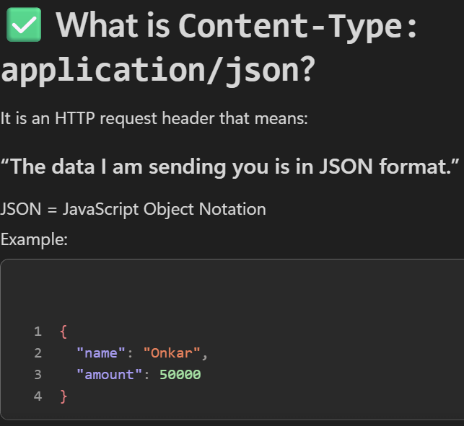

Finance and operation integration
F&O integration
13 January 2026
10:50

Company -

  - Represents a legal entity within your organization.
  - Each company has its own financial records, transactions, and policies.
  - Examples: USMF, GBSI (legal entities in F&O).

Vendor
  - Represents an external supplier from whom you purchase goods or services.

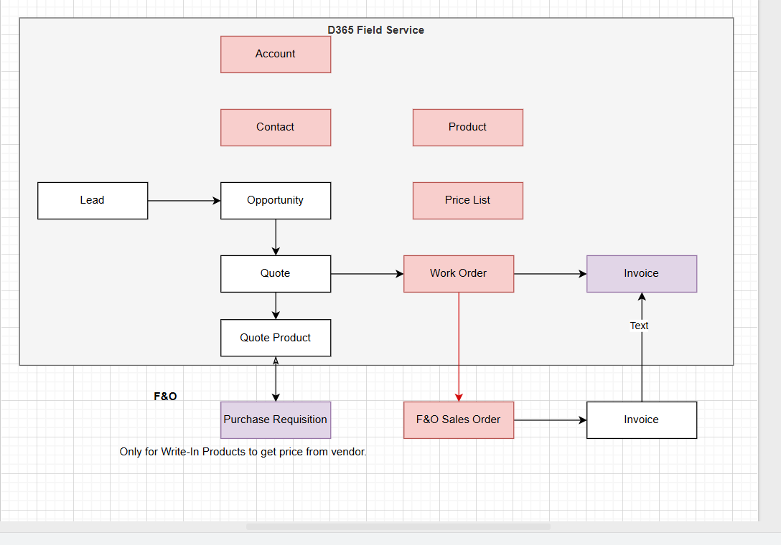

Customization
13 February 2026
11:35

- Company lookup in Account ,contact , wo , quote

Account -> Customer
Contact -> Contact person

In F&O There is middle entity as part for accounts and contacts

Account =>
Customer group
A Customer Group in F&O is used to categorize customers for financial, posting, pricing, and reporting purposes.

E.g
- Zone based customer group

In fiesa customers group can be categorized based can be based on
Customer type => B2B or B2C

B2B = Business to business
B2C = Business to customer

- Inventory lot id in sales order lines in f&O and diff between lot id and inventory =>

Example Scenario: Medicine Stock with Batch Tracking
Your company receives a shipment of 200 bottles of Paracetamol (Item ID = MED100).
The supplier sends two different batches (lot numbers):

Batch A: LOT-001
Qty = 120
Expiry = 31-Dec-2027

Batch B: LOT-002
Qty = 80
Expiry = 31-Dec-2028

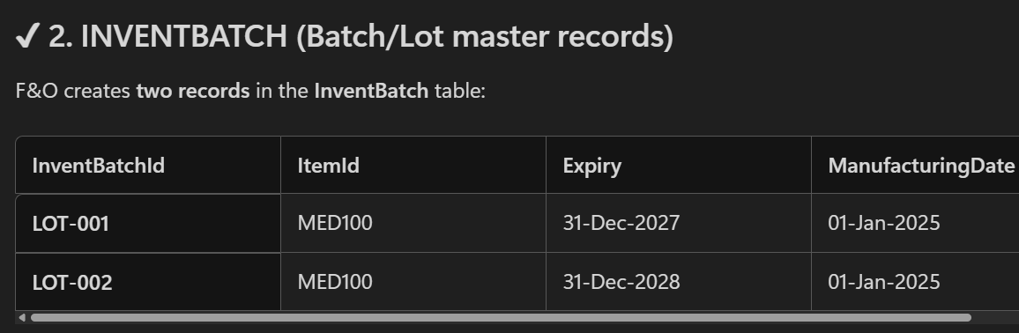

SO the product should have both Inventory lookup as well batch id/inventory lot id

- Purchase Requisition
- Purchase Requisition is used only when your organization internally needs to buy the items required to fulfill the Work Order or Sales Order
- PR is an internal request to purchase items the organization needs.
- Once Sales Order lines exist, F&O checks availability:
❌ If inventory is available → No PR needed
✔️ If inventory is NOT available → Create PR for the missing items

Direction
13 February 2026
12:46

Entity (F&O -- CRM) | Direction
Released Product --> Product | Unidirection => F&O to crm
Pricelist | Unidirection => F&O to crm
Customer <--> Account | Bidirectional
Contact <--> contact person | Bidirectional
Work order --> Sales order | Unidirectional => CRM to F&O
Work order -- > Sales order lines | Unidirectional => CRM to F&O
Unit --> Unit | Unidirectional => F&O to CRM

Business Central Integration
Why?
15 January 2026
16:13

- When you complete a work order in Field Service, the integration enables the smooth transfer of data to Business Central for further processing.

- The integration also lets you invoice and fulfill work orders in Business Central. You can generate accurate invoices based on the service activities and the consumption recorded in Field Service.

3 .Depending on the business processes you need, you can integrate Field Service with project management features only, or project management and service management features in Business Central.

Integration approaches
27 January 2026
00:25

Quick “Which one should I pick?” decision guide
Pick Power Automate if:
- You need business workflows + Microsoft 365 integration (Teams, approvals)
- You want quick build and easier maintenance [learn.microsoft.com], [learn.microsoft.com]
Pick Custom API + HTTP/Custom Connector if:
- You need custom fields or BC-side custom logic [learn.microsoft.com], [learn.microsoft.com]
Pick Azure Functions / direct REST API middleware if:
- You need performance, high volume, complex mapping, batch processing
- You want robust telemetry/error handling [learn.microsoft.com], [learn.microsoft.com]
Pick OData if:
- Quick read-heavy integrations, reporting-like needs
- But APIs are generally recommended for integration

Entities
27 January 2026
00:33
what are the standard entities to be considered in field service crm integrating with business central -
Below is a clear, practical, Field-Service–focused list of the standard entities that are typically considered when integrating Dynamics 365 Field Service (CRM) with Business Central (ERP).
I’ll structure it in the correct architectural order, and I’ll also explain why each entity matters so you can confidently justify it in design discussions.

1. Core Master Data (Foundation – MUST HAVE)
These entities form the base of any Field Service ↔ Business Central integration.
1.1 Accounts (CRM) ↔ Customers (BC)
Most critical integration
Field Service (CRM) | Business Central
Account | Customer
Why integrate
  - Field Service uses Accounts for customers receiving service
  - Business Central uses Customers for billing, invoicing, and ledger postings
  - Sales Orders, Work Orders, and Invoices all depend on this link
✅ Usually bidirectional
✅ Requires ID mapping (CRM AccountId ↔ BC Customer SystemId)

1.2 Contacts (CRM) ↔ Contacts (BC) (Optional but common)
Field Service | Business Central
Contact | Contact
Why integrate
  - Onsite contacts, dispatch contacts, billing contacts
  - Often linked to Account/Customer
⚠️ Usually CRM → BC only, not mandatory for financial transactions

2. Product & Item Data (Inventory Backbone)
2.1 Products (CRM) ↔ Items (BC)
Field Service | Business Central
Product | Item
Why integrate
  - Products are used in:
  - Work Order Products
  - Services
  - Inventory consumption
  - BC Items control:
  - Stock
  - Costing
  - Posting Groups
✅ Typically BC → CRM (ERP is source of truth)

2.2 Price Lists (CRM) ↔ Sales Prices / Price Lists (BC)
Why integrate
  - Field Service needs correct pricing during service execution
  - Business Central owns pricing logic
⚠️ Often one-way (BC → CRM)
⚠️ Sometimes replaced with manual CRM pricing

3. Asset & Service Context (Field Service–Specific)
3.1 Customer Assets (CRM)
CRM-only entity
Why
  - Represents equipment installed at customer site
  - Drives:
  - Preventive maintenance
  - Repairs
  - Asset-based Work Orders
✅ Usually not synced to BC as Items ✅ Financial impact occurs only when services/products are used

4. Work Execution Entities (Operational Core)
4.1 Work Orders (CRM) ↔ Sales Orders (BC)
Field Service | Business Central
Work Order | Sales Order
Why integrate
  - Work Order represents service execution
  - Sales Order represents billable transaction
✅ Common pattern:
  - Work Order completed → Sales Order created in BC
  - Not a 1-to-1 header mapping, but business-event-driven

4.2 Work Order Products (CRM) ↔ Sales Order Lines (BC)
Field Service | Business Central
WO Products | Sales Order Lines
Why integrate
  - Parts consumed during service must be billed
  - Inventory impact happens in BC
✅ Usually CRM → BC ✅ Quantity, Item, Price passed for invoicing

4.3 Work Order Services (CRM) ↔ Service Lines / Charges (BC)
Field Service | Business Central
WO Services | Service Lines / G/L Lines
Why integrate
  - Labor & service charges need to be invoiced
  - BC handles revenue recognition

5. Resource & Scheduling (Mostly CRM-Side)
5.1 Bookable Resources (CRM)
CRM-only
  - Technicians
  - Crews
  - Scheduling
✅ Not typically synced to BC
✅ Payroll / cost handled indirectly via financial postings

6. Inventory & Warehouse Interaction (Advanced Scenario)
6.1 Warehouses (CRM) ↔ Locations (BC)
Field Service | Business Central
Warehouse | Location
Why integrate
  - Determines where inventory is consumed from
  - Supports mobile/van stock scenarios
✅ Mostly BC → CRM

6.2 Inventory Adjustments / Consumption
  - Work Order Product usage
  - Triggers inventory movement in BC
✅ Event-based sync, not table sync

7. Financial Outcome Entities (ERP-Owned)
7.1 Invoices (CRM) ↔ Posted Sales Invoices (BC)
Field Service | Business Central
Invoice | Posted Sales Invoice
Why
  - BC is system of record for finance
  - Posted documents rarely flow back to CRM
✅ Usually BC → CRM (read-only)

7.2 Payments (BC only)
  - Payments
  - Ledger Entries
✅ Not synced to Field Service
✅ CRM may show balance via read-only integration

8. Recommended Integration Classification
✅ Must-Have (Core)
  - Account ↔ Customer
  - Product ↔ Item
  - Work Order → Sales Order
  - Work Order Products → Sales Lines
✅ Good-to-Have
  - Contacts
  - Customer Assets (CRM only)
  - Price Lists
  - Invoice visibility
⚠️ Usually Not Synced
  - Field Service scheduling entities
  - Resource availability
  - Internal BC ledger tables

9. Typical Integration Direction Summary
Entity | Direction
Customer / Account | Bidirectional
Item / Product | BC → CRM
Work Order | CRM → BC
Sales Order | BC (created from CRM event)
Invoice | BC → CRM (optional)
Inventory | Event-based

10. One-Line Architecture Summary (Interview-Ready)
In a Field Service and Business Central integration, CRM manages service execution and scheduling, while Business Central remains the system of record for inventory, pricing, and financial transactions. Integration is designed around event-based flows rather than direct table synchronization.

Company
27 January 2026
01:04

Company - Nsquare india
- Has its separate rule , regulations , taxes these can not be applied to the nsquare usa
- Nsquare pune or nsquare banglore -- creating both not required
Company - Nsquare usa

Service management

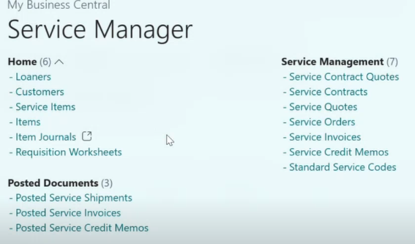

If you cannot edit permission sets, you need an Admin to do it. - who is this admin
->
Microsoft 365 Global Administrator (highest)
This is the main admin of your entire Microsoft tenant.
This person can:
- Assign BC SUPER permission
- Access Business Central Admin Center
- Create environments
- Manage users & licenses
- Reset your permissions
- Do every admin action in Microsoft 365 + Dynamics ecosystem
This is usually:
- The person who created the tenant
- Your IT administrator
- Your organisation’s Microsoft 365 admin
- Whoever manages Office/Dynamics licenses

⭐ 2. Dynamics 365 Administrator
This role can also assign BC permissions.
This person can:
- Manage Dynamics apps
- Assign BC permission sets
- Access Business Central admin center

🎯 IMPORTANT:
JUST having Business Central access is NOT enough.
You CANNOT assign SUPER to yourself unless:
You are already:
- Global Administrator, OR
- Dynamics 365 Administrator, OR
- Someone who already has SUPER in BC

How to find out who is the Admin?
1. Go to:
https://admin.microsoft.com
If you can open it, then:
- Look at Roles → Global admin
- If you see other users listed there, those are your admins.
If you cannot open it: 👉 That means you are NOT an admin.
Then ask your IT team:
- “Who is the Microsoft 365 Global Admin for this tenant?”

Inventory
Product inventory
21 January 2026
13:14

Reorder Point
- Minimum threshold quantity.
- A warning is triggered when Quantity Available < Reorder Point.
- Used for replenishment planning.

Row
- Additional warehouse structure (Row → Bin → Unit).
- Optional—used for detailed location mapping.

Quantity On Hand
- Actual physical stock in the warehouse.

Quantity Allocated
- When the products are allocated for any work order but not used yet

Quantity Available = Quantity On Hand – Quantity Allocated
- Remaining products after the quantity allocation

Quantity On Order

- Inventory that you have ordered from vendors but not yet received. - Create purchase order and submitted

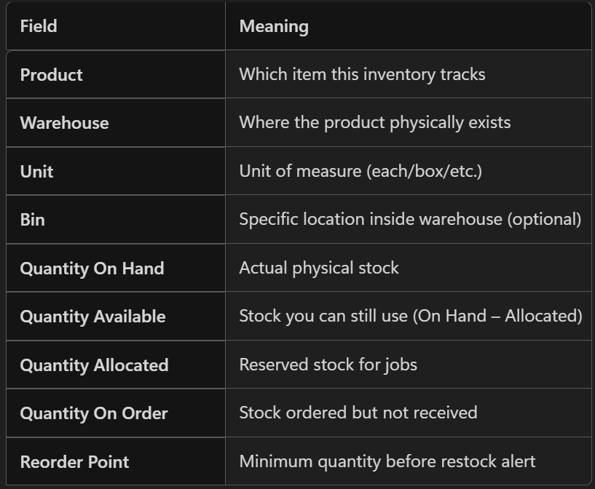

RMA (Return Merchandise Authorization)
Purpose: Customer → company returns
This handles cases when a customer returns a product to your company.

RMA Receipt
Purpose: Confirm physical arrival of returned items
After the customer sends the product back, you receive it into the warehouse.

RTV (Return to Vendor)
Purpose: Company → vendor return
This is used when you return inventory items back to the supplier.

Purchase Order (PO)
Purpose: Buy new inventory from vendors
A PO is created when you need to order stock.

Receipt (PO Receipt)
Purpose: Confirm the products from a purchase order have arrived
This updates inventory.

Inventory Adjustment vs Purchase Orders in Dynamics 365 Field Service
1. Inventory Adjustment (Manual Stock Correction)
What it is:
A direct manual change to inventory quantity when actual physical stock does not match the system.

2. Purchase Order (Buying Items from Vendors)
What it is:
A formal document used to procure inventory from an external vendor.

Create RTVS
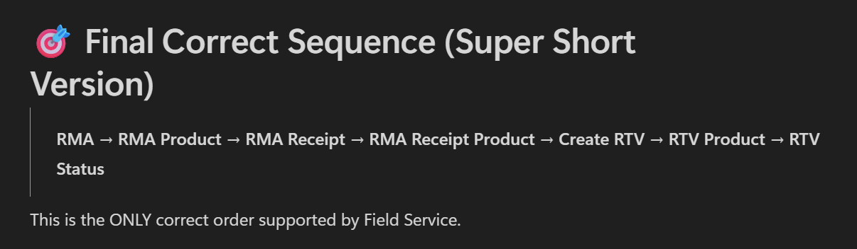

Correct Order to Create an RTV (Return to Vendor)

Below is the exact sequence you must follow, otherwise you will get errors like
“quantity processed can’t be greater than quantity received.”

1️⃣ Create the RMA (Return Merchandise Authorization)
Start the return process by creating an RMA:
Field Service → Inventory → RMAs → New
This defines:

Customer returning item
Work order (optional)
Substatus
Ship Via

2️⃣ Add RMA Products
Add the item(s) the customer is returning:

Add RMA Product manually, or
Add products from Work Order

3️⃣ Create RMA Receipt (When customer physically returns item)
You must confirm that your company has received the item before RTV can be created.
Inside RMA:
Related → Receipts → New RMA Receipt

4️⃣ Add RMA Receipt Products (Actual quantity received)
This is the MOST IMPORTANT step.
Inside RMA Receipt:
Related → Receipt Products → New RMA Receipt Product
Here you enter:

Product
Quantity actually received

This quantity controls what RTV can process.
👉 If this step is missing, RTV creation/processing will fail.

5️⃣ After RMA Receipt is complete → Create RTV
Once items are received into your warehouse, create the RTV from the RMA:
In the RMA command bar:
Create RTV → OK
RTV record is created automatically.

6️⃣ Open the RTV and Update RTV Products
Navigate to:
Field Service → Inventory → RTVs → Open RTV
Add/update:

RTV Products
Quantity to send back to vendor

⚠ Field Service plugin validates:

RTV Processed Quantity ≤ RMA Receipt Quantity
This is why quantity must match receipt.

7️⃣ Update RTV Status (Optional)
Update the RTV System Status as the item moves:

Approved
Shipped
Received
===================================================================

How to Create an RMA (Return Merchandise Authorization) in Field Service
Microsoft defines a clear sequence for creating an RMA.
All steps below come directly from official documentation.

1️⃣ Navigate to RMAs
Go to:
Field Service → Inventory → RMAs → New
This opens a new RMA record.

2️⃣ Fill in Key RMA Fields
When creating an RMA:
✔ Work Order (Optional)
If the return relates to a work order, select it.
- The Service Account will auto-fill.
✔ Substatus
Used for tracking the reason or stage of the return.
Examples:
- Exchange
- Repair
- Retire
- Upgrade
✔ Ship Via (Optional)
How the customer will send the item back.
Examples:
- FedEx
- USPS
- Freight shipping
After entering information → Click Save.

3️⃣ Add RMA Products (Items being returned)
You can add products in two ways:

A. Add Products Manually
Inside the RMA Record → Products section → Add RMA Product Record
Enter:
- Product
- Quantity
- Return Type (Return to warehouse / Change of ownership, etc.)
- Warehouse (if the item is inventory tracked)
Then Save & Close.

B. Add Products from a Work Order
(Only available if RMA is linked to a Work Order)
On the RMA command bar → Add WO Products
This automatically pulls the items used on the WO.
Select the product(s) → OK

4️⃣ Receive the Returned Product (RMA Receipt)
This step occurs when the customer physically sends the product back.
Inside the RMA →
Related → Receipts → New RMA Receipt
Fill in details → Save.

5️⃣ Add RMA Receipt Products (Actual Quantity Received)
This is where you record what was actually received.
Inside RMA Receipt:
Related → Receipt Products → New RMA Receipt Product
Enter:
- RMA Product
- Quantity Received
→ Save & Close
📌 Important:
For inventory-tracked products, this creates an inventory journal that increases warehouse stock.

6️⃣ (Optional) Create an RTV (Return to Vendor)
If the received item must be sent to a vendor:
On the RMA command bar → Create RTV → OK

🎯 Interview-Ready Summary
To create an RMA in Field Service:
Go to Field Service → Inventory → RMAs → New.
Enter details, add RMA Products, then create an RMA Receipt and Receipt Products when the item is returned.
If the item must be sent to a vendor, generate an RTV from the RMA.

🔍 What actually increases inventory?
Only ONE action increases inventory:
Adding an RMA Receipt Product for an RMA whose Return Type = Return to Warehouse
[learn.microsoft.com]
Microsoft confirms:
“An inventory journal increases the on-hand quantity in the warehouse by the quantity of the RMA Receipt Product.”
[learn.microsoft.com]
But this only happens IF:
Return Type = Return to Warehouse
NOT when Processing Action = Create RTV.

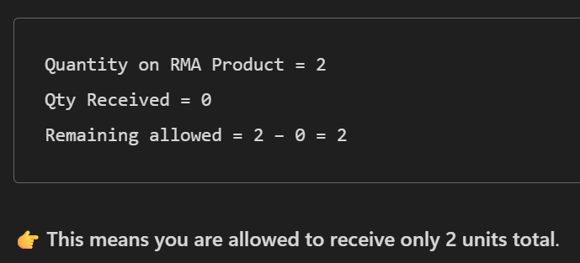

Prechanged quantity
. Prechanged Quantity
Internal old value of the receipt line before you edit it.
- Exists only on RMA Receipt Product
- It is NEVER shown on the form
- It is used ONLY for validation calculation:
New Quantity – Prechanged Quantity
- If the receipt line is new, prechanged quantity = 0
- If the receipt line already exists, prechanged quantity = old saved quantity on that line
Example:
Old receipt line quantity = 2
You change it to 5
Prechanged Quantity = 2
New Quantity = 5
Changed Value = 3

Prechanged Quantity -

E.g Scenario -

- The previous quantity on a rma receipt
e.g => Previous =1
Changed =3

Rma quantity =2
Received =1

(3-1)=2>(2-1)=1
Allowed value =2

(2-1)=1 == (2-1) =1

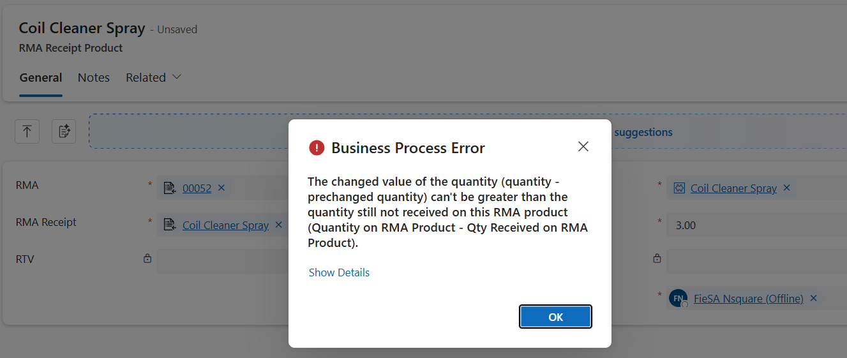

RMA - Return to inventory
1. Create RMA
2. Create RMA product
3. Processing action - Return to warehouse
4. Create the rma receipt
5. Set quantity --> RMA will be received

RMA -RTV
1. Create a RMA - use create RTV
2. Create a RMA Product
3. Create a RMA Receipt --> create a receipt product
3. Create a RTV using the RMA

Quantity allocation does not reduces the quantity on hand in inventory so even though the products are allocated it does not reduces/deducts quantity from the inventory(quantity on hand) the
For example -
Product 1 Quantity on hand =6
Allocated quantity = 4 to work order quantity on hand = 6
Product used quantity = 2 quantity on hand =4
Remaining quantity of allocated product =2
Even though the allocated product is 4 the product quantity will reduce based on quantity used
- Technician get the quantity physically only when the work order is marked as used and allocated
- Allocation only reserves the items in inventory so others cannot take them.
- Technician only receives products when:
- They collect material from warehouse (via Issue Inventory, Inventory Transfer, or Stock Movement)
- They mark “Used Quantity” on the Work Order

Scenarios
02 February 2026
12:55

I allocated the product first to work order then quantity in hand 9 and quantity availaible = 6 then created the rma and then rma receipt using the create the rtv the then created the rtv what should the inventiry behaviour

Below is the exact Microsoft-supported inventory behavior for the scenario you described.
I will break it down step-by-step so you understand why your numbers look the way they do.
All explanations are based strictly on Microsoft documentation.
microsoft+1

🧩 Your Scenario (Step-by-Step)
Let’s recap what you did:
  - Allocated product to Work Order
  - Quantity on Hand = 9
  - Quantity Available = 6
(This means 3 units are allocated to the WO, so not available.)
microsoft
  - Created RMA with Processing Action = Create RTV
  - Created RMA Receipt for the product
  - Created RTV
Now you want to know:
👉 What should the inventory behavior be?

✅ Correct Inventory Behavior According to Microsoft
Step 1 — Before RMA: Allocation happens
When you allocate the product to a Work Order:
  - Quantity On Hand stays 9
  - Quantity Available drops to 6
Because “Quantity Allocated” becomes 3.
microsoft
✔ This part of your behavior is correct.

❗ Step 2 — You created the RMA + RMA Receipt with Processing Action = Create RTV
This is the key point:
👉 "Create RTV" means the product is NOT being returned to your warehouse.
It means the product will be forwarded to the vendor instead.
d365hub
Therefore:
🟥 Your inventory WILL NOT increase.
Even after creating the RMA Receipt.
Microsoft says inventory only increases when RMA Receipt is for Return to Warehouse.
microsoft
Since your RMA Processing Action = Create RTV, the system treats the return as:
Customer → Your Company → Vendor
(Not going into warehouse)
So:
  - Quantity On Hand does NOT increase
  - Quantity Available does NOT increase
✔ This is expected behavior.

❗ Step 3 — When you create RTV
RTV removes inventory from your warehouse ONLY IF the product was previously returned to warehouse.
But in your case:
You never returned it to warehouse → Only to vendor.
So:
  - RTV will not deduct warehouse quantity, because nothing was added earlier.
✔ Inventory remains unchanged.

Final Inventory Behaviour for Your Case
Stage | Qty On Hand | Qty Available | Why
After WO Allocation | 9 | 6 | 3 units allocated to WO (standard behavior)
After RMA Receipt (Processing Action = Create RTV) | 9 | 6 | Because product is NOT returned to warehouse [learn.microsoft.com]
After RTV Creation | 9 | 6 | RTV does not reduce anything because nothing was added to warehouse

🟩 If you WANT inventory to increase…
If your business flow is:
Customer returns item → You take it into your warehouse → Then you send it to vendor
Then you must:
✔ Set RMA Product → Return Type = Return to Warehouse
(Processing Action should NOT be Create RTV)
✔ Create RMA Receipt
→ Inventory increases (Microsoft says RMA Receipt increases On-hand)
[learn.microsoft.com]
✔ Then manually create RTV
→ Inventory decreases (vendor return)
This is the classic and correct flow.

🎯 Final Answer (Very Simple)
Because your RMA was set to Create RTV, the product is treated as a vendor return, not a warehouse return.
Therefore the RMA Receipt does NOT increase warehouse inventory, and the RTV does NOT decrease it.
Inventory stays exactly the same.

Fiesa – Bugs
Dash board record blank
19 January 2026
18:34

  - Removed the work order where there case , quote , bookings are blank
  - Deleted the bookings where there associated work order record don’t have the case , quote and agreement
  - Deleted the work orders where the case , quote , agreement are blank

Work order - Duplicate products , services and service tasks created
03 February 2026
12:59

- There is a system plugin runs whenever the work order is created then it creates the products , services and service tasks
- There was a custom plugin to create this records so the duplicate records were created
- For the Work order type = Inspection and preventive maintainance the records getting created but for Work order type = reactive maintainance were not getting created
Reason = On work order type record incident required was "NO" for Reactive .So the whenever the work order created the work order incident was not getting created (internally) so the work order products ,services and service task were also not getting created.

What I did ?
- For Work order type = reactive maintainance
Set Incident required was "Yes"
- Disabled the custom plugin

Work order - Automatic allocation of warehouse
03 February 2026
13:06

- Created a plugin for automatic allocation of warehouse on create of work order product
- Plugin name -NSQ.FIESA.Action.AutoCreateWorkOrderAndBooking: nsq_JobSchedulingGenerateWOBookings
- It sets the warehouse of product inventory automatically on create of work order product
- Kept allocated = false as it is (Also the OOB is false)

Interesting fact -
If Allocated = True
The if product is not in any product inventory and warehouse then system plugin get triggered and creates the product inventory for that particular product . The system plugin triggers to create inventory journal

